CS 5700

Fundamentals of Computer Networking

Fall 2024

### Instructor Contact

Dr. Lama Hamandi l.hamandi@northeastern.edu

Office Hours:

**Fridays 11:00-12:30pm (on campus, Room 1018)**

**Tuesdays 11:00-12:30PM (online) -**Zoom link for Office Hours:

[**https://northeastern.zoom.us/j/97122480313**](https://northeastern.zoom.us/j/97122480313)

**TAs:**

Mozhi Shen                             [shen.moz@northeastern.edu](mailto:shen.moz@northeastern.edu)

Haozhe (Jason) Zhang            [zhang.haozhe1@northeastern.edu](mailto:zhang.haozhe1@northeastern.edu)

**Scheduling Meetings:** At any time during the course, if you have any questions, send them on piazza. Posting is anonymous. Anyone can answer any question. You are also encouraged to visit us during our office hours. If you’re not available during these OH, you can also send a private message on piazza for me or the TAs and we will set up a meeting at a mutually convenient time.

**Textbook**: Computer Networking: A Top Down Approach, 8th (or 7th) edition, by Jim Kurose, Keith Ross

Link to 7th edition of textbook:

<https://www.ucg.ac.me/skladiste/blog_44233/objava_64433/fajlovi/Computer%20Networking%20_%20A%20Top%20Down%20Approach,%207th,%20converted.pdf>

**Reference Book**: Computer Networks: A Systems Approach, 6th ed

By Larry Peterson, Bruce Davie

Link to chapters: <https://book.systemsapproach.org/>

Link to the Book: <https://github.com/SystemsApproach/book/releases/download/v6.1/book.pdf>

What is a Computer network?

At least two devices connected by a communication medium allowing them to communicate electronically.

* 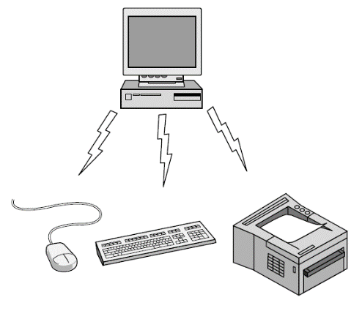ex: a Bluetooth (wireless) Personal Area network (PAN)
* 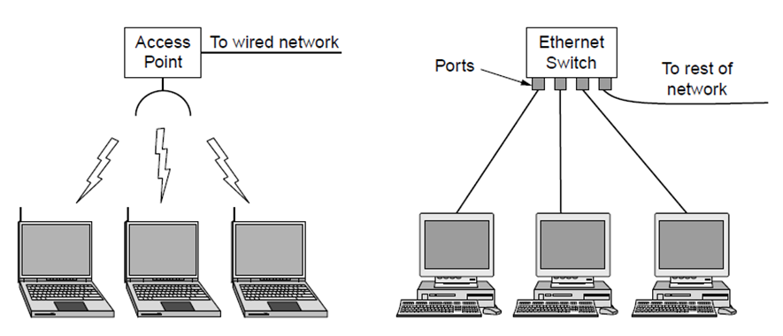ex: Wireless Local Area Network (LAN) with Wi-Fi (802.11)
* ex: Wired LAN with “switched Ethernet”

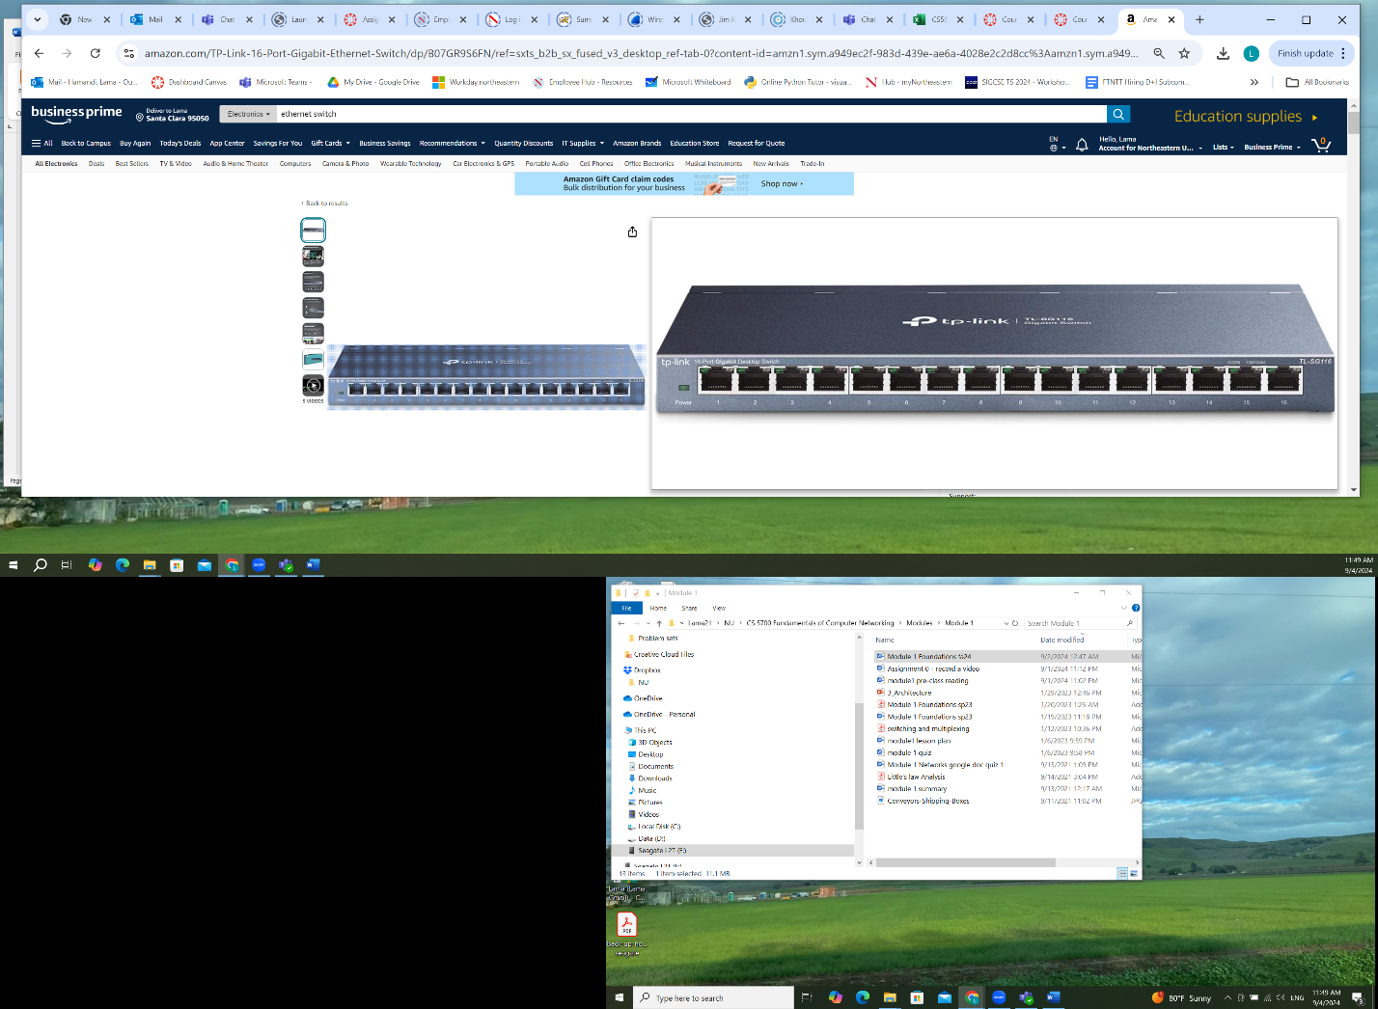

* ex: The **Internet**:“network of networks”

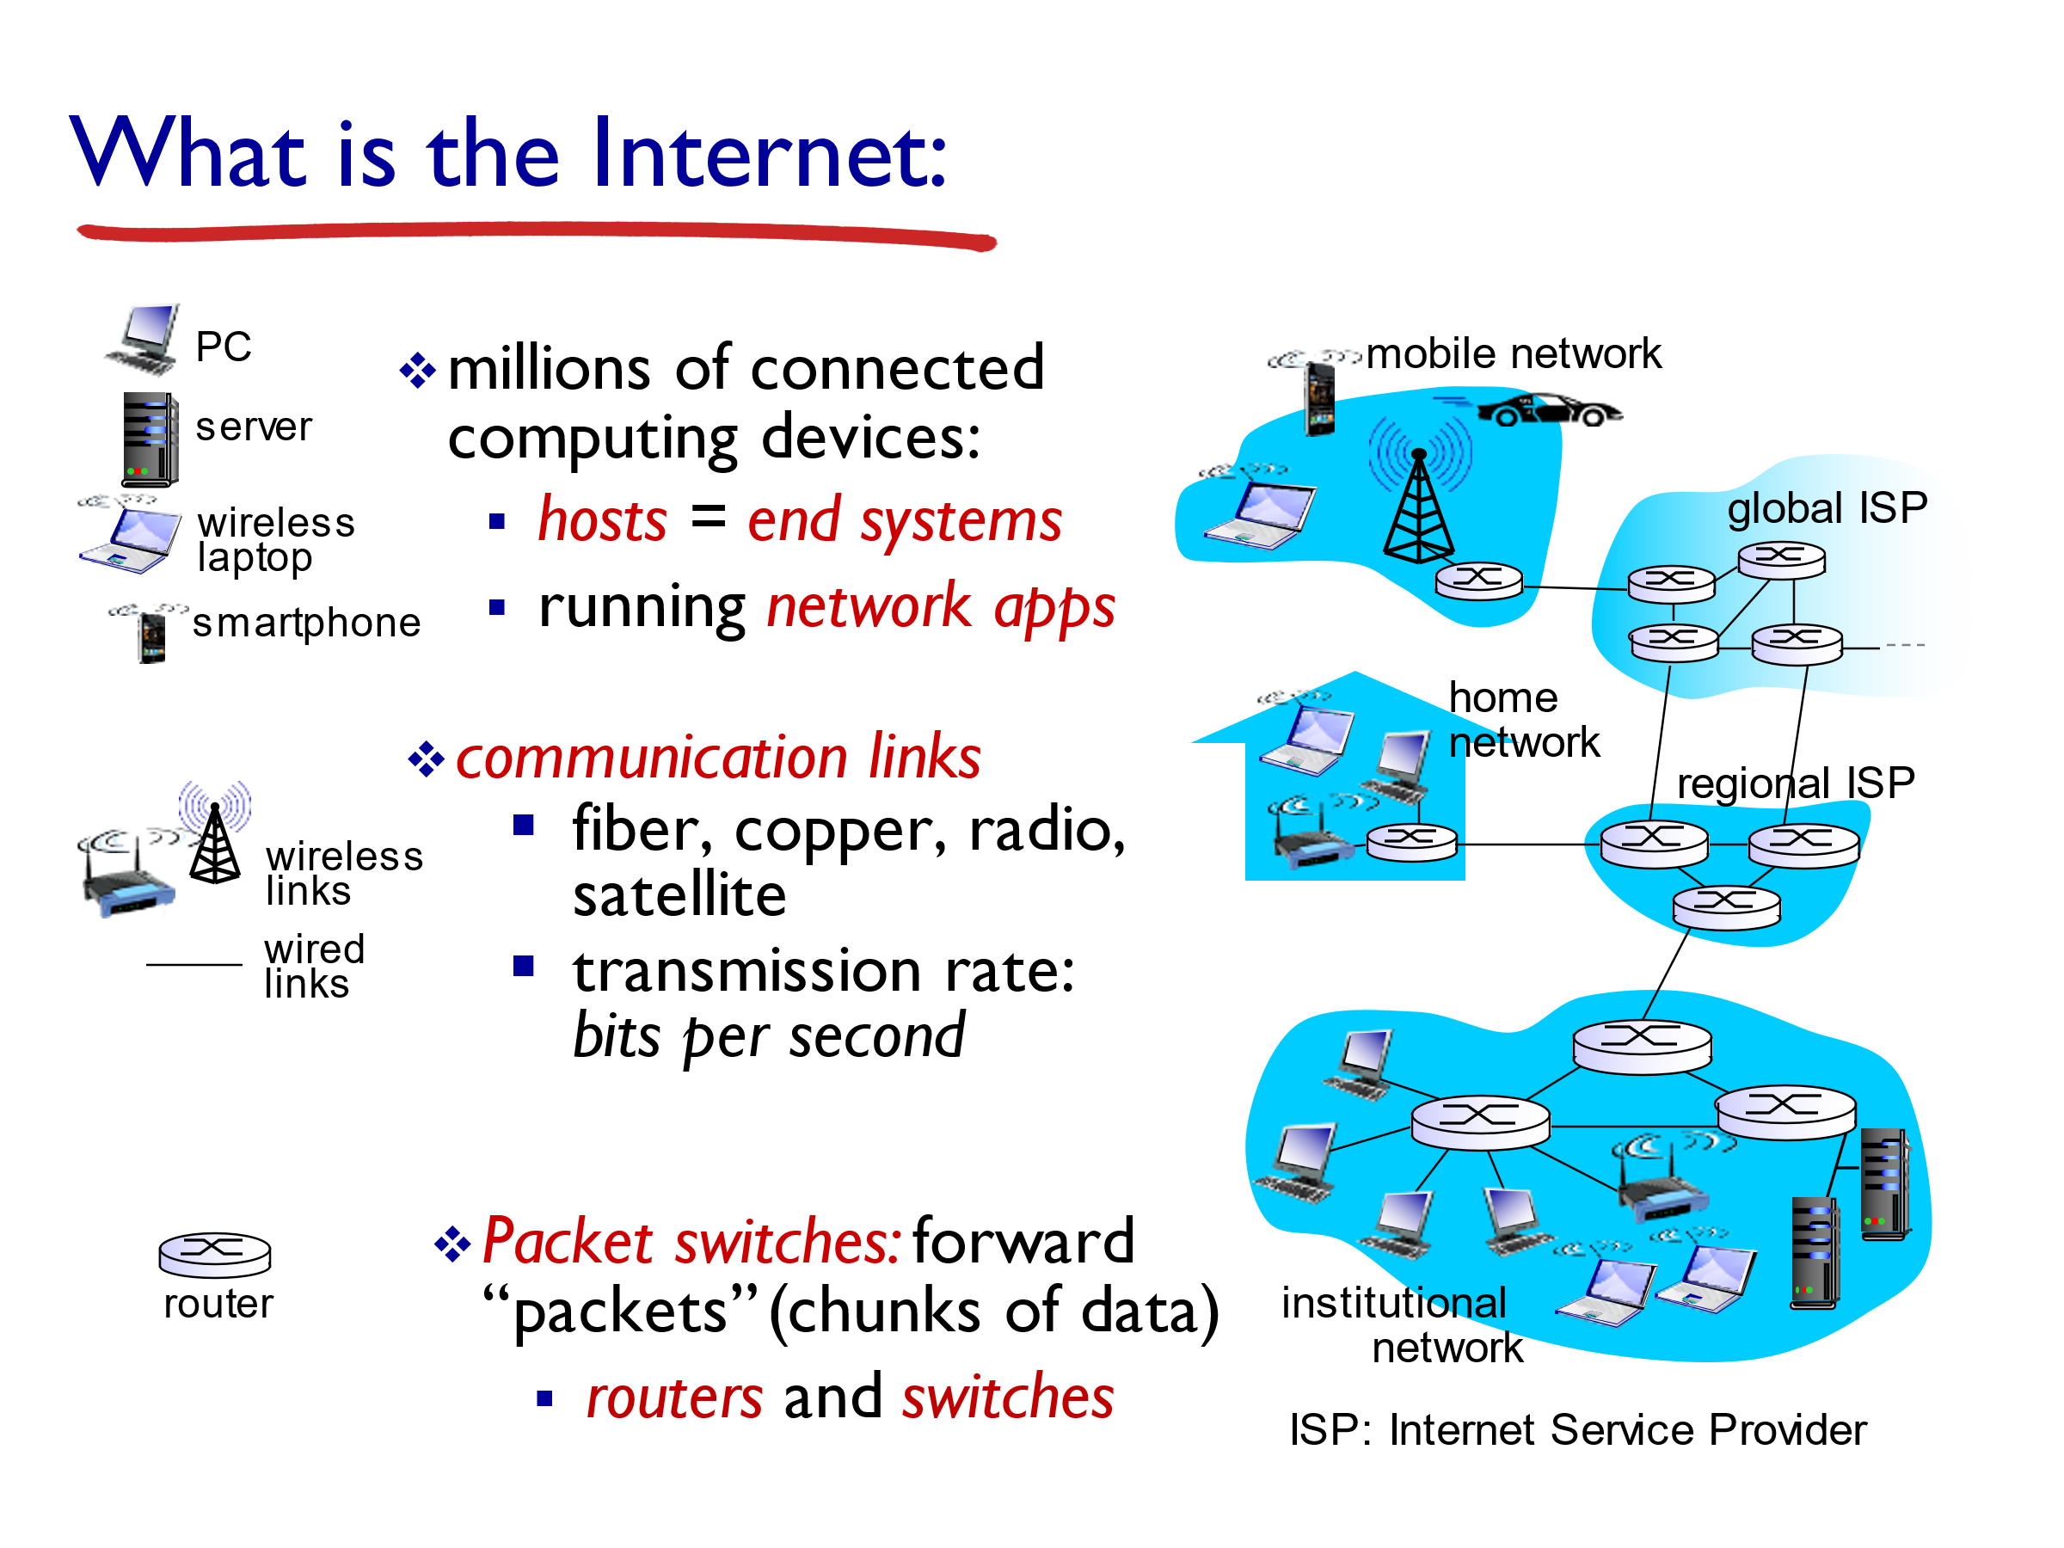

Customers buy connectivity from the ISP to use it

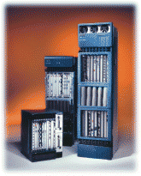

Large router

Small switch

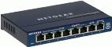

Fiber Optic cable

Coaxial Cable

A network application is **any application running on one host providing communication to another application running on a different host**.

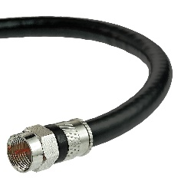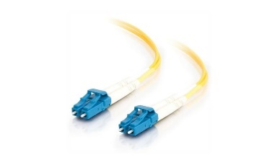

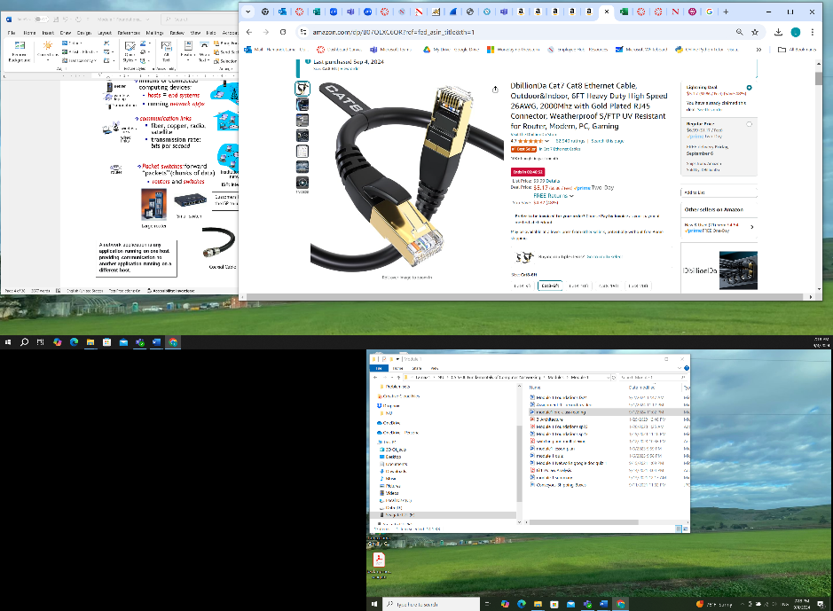

Ethernet cable

Let us uncover the topics that we will study in this course.

To do that answer Discussion 1:

If you are trying to design a network (or the internet) from scratch (to send messages to your friend for example) what are some of the functions and components that you need to design?

**Discussion 1 Solution:**

authentication, composing and sending the message. Connection medium, establishing a connection, retrieving messages from inbox, breaking message into pieces or packets, including address of sender and address of receiver, translate john@eis.utoronto.ca into address of john’s computer, use this address to decide on the route/links to send the message to, take action in case of collision, check if arrived message is corrupted, take action if it is corrupted, reconstruct pieces at receiver, Take action if a link/router fails or becomes congested, How my English sentences are actually propagating onto the physical media connecting my laptop to john’s laptop, multiplexing – demultiplexing, Design switches, routers, …

Application layer - transport layer- Network layer - link layer - physical layer

**Learning Outcomes**

At the end of the course, students:

* Understand the basic principles of computer networking, and how network applications communicate
* Basically, you should be able to understand the steps listed above which are needed when you use the internet

In each lecture, I will ask a set of questions and you will help me in answering these questions.

**Question #1**

**Based on your pre-class readings, define and compare** packet switching and circuit switching,

**then** time division multiplexing, frequency division multiplexing**, and *statistical multiplexing.***

Use at most one sentence for each of the four definitions.

**Packet Switching versus Circuit Switching**

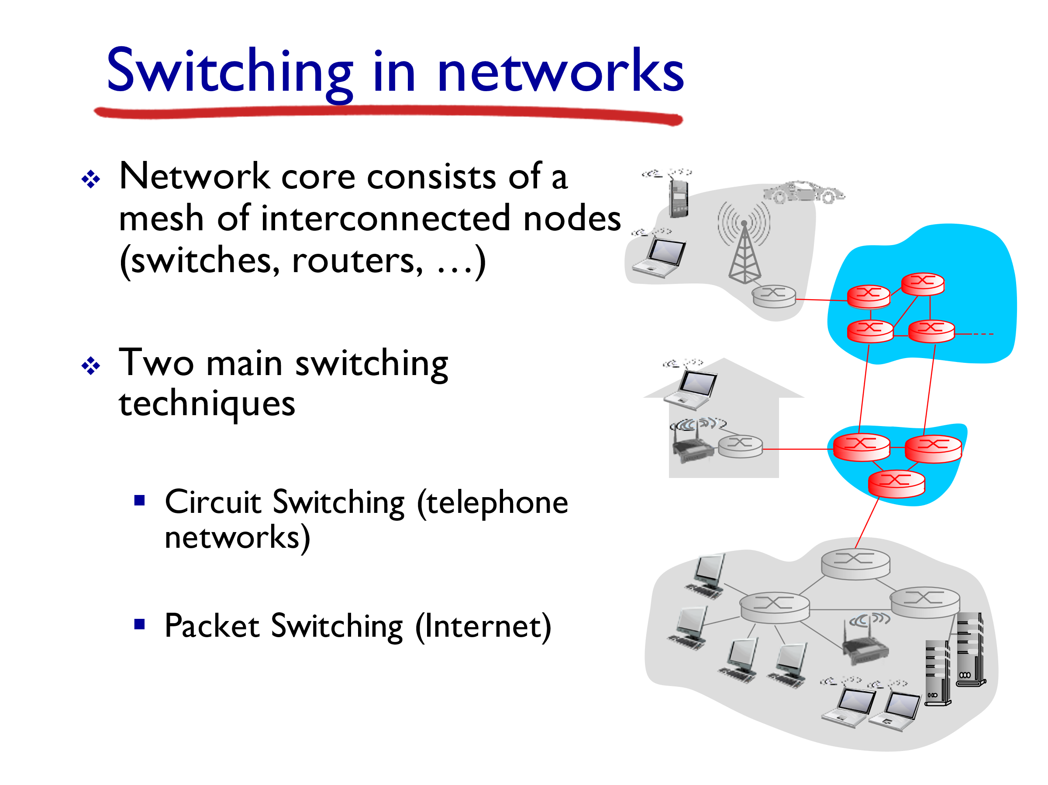

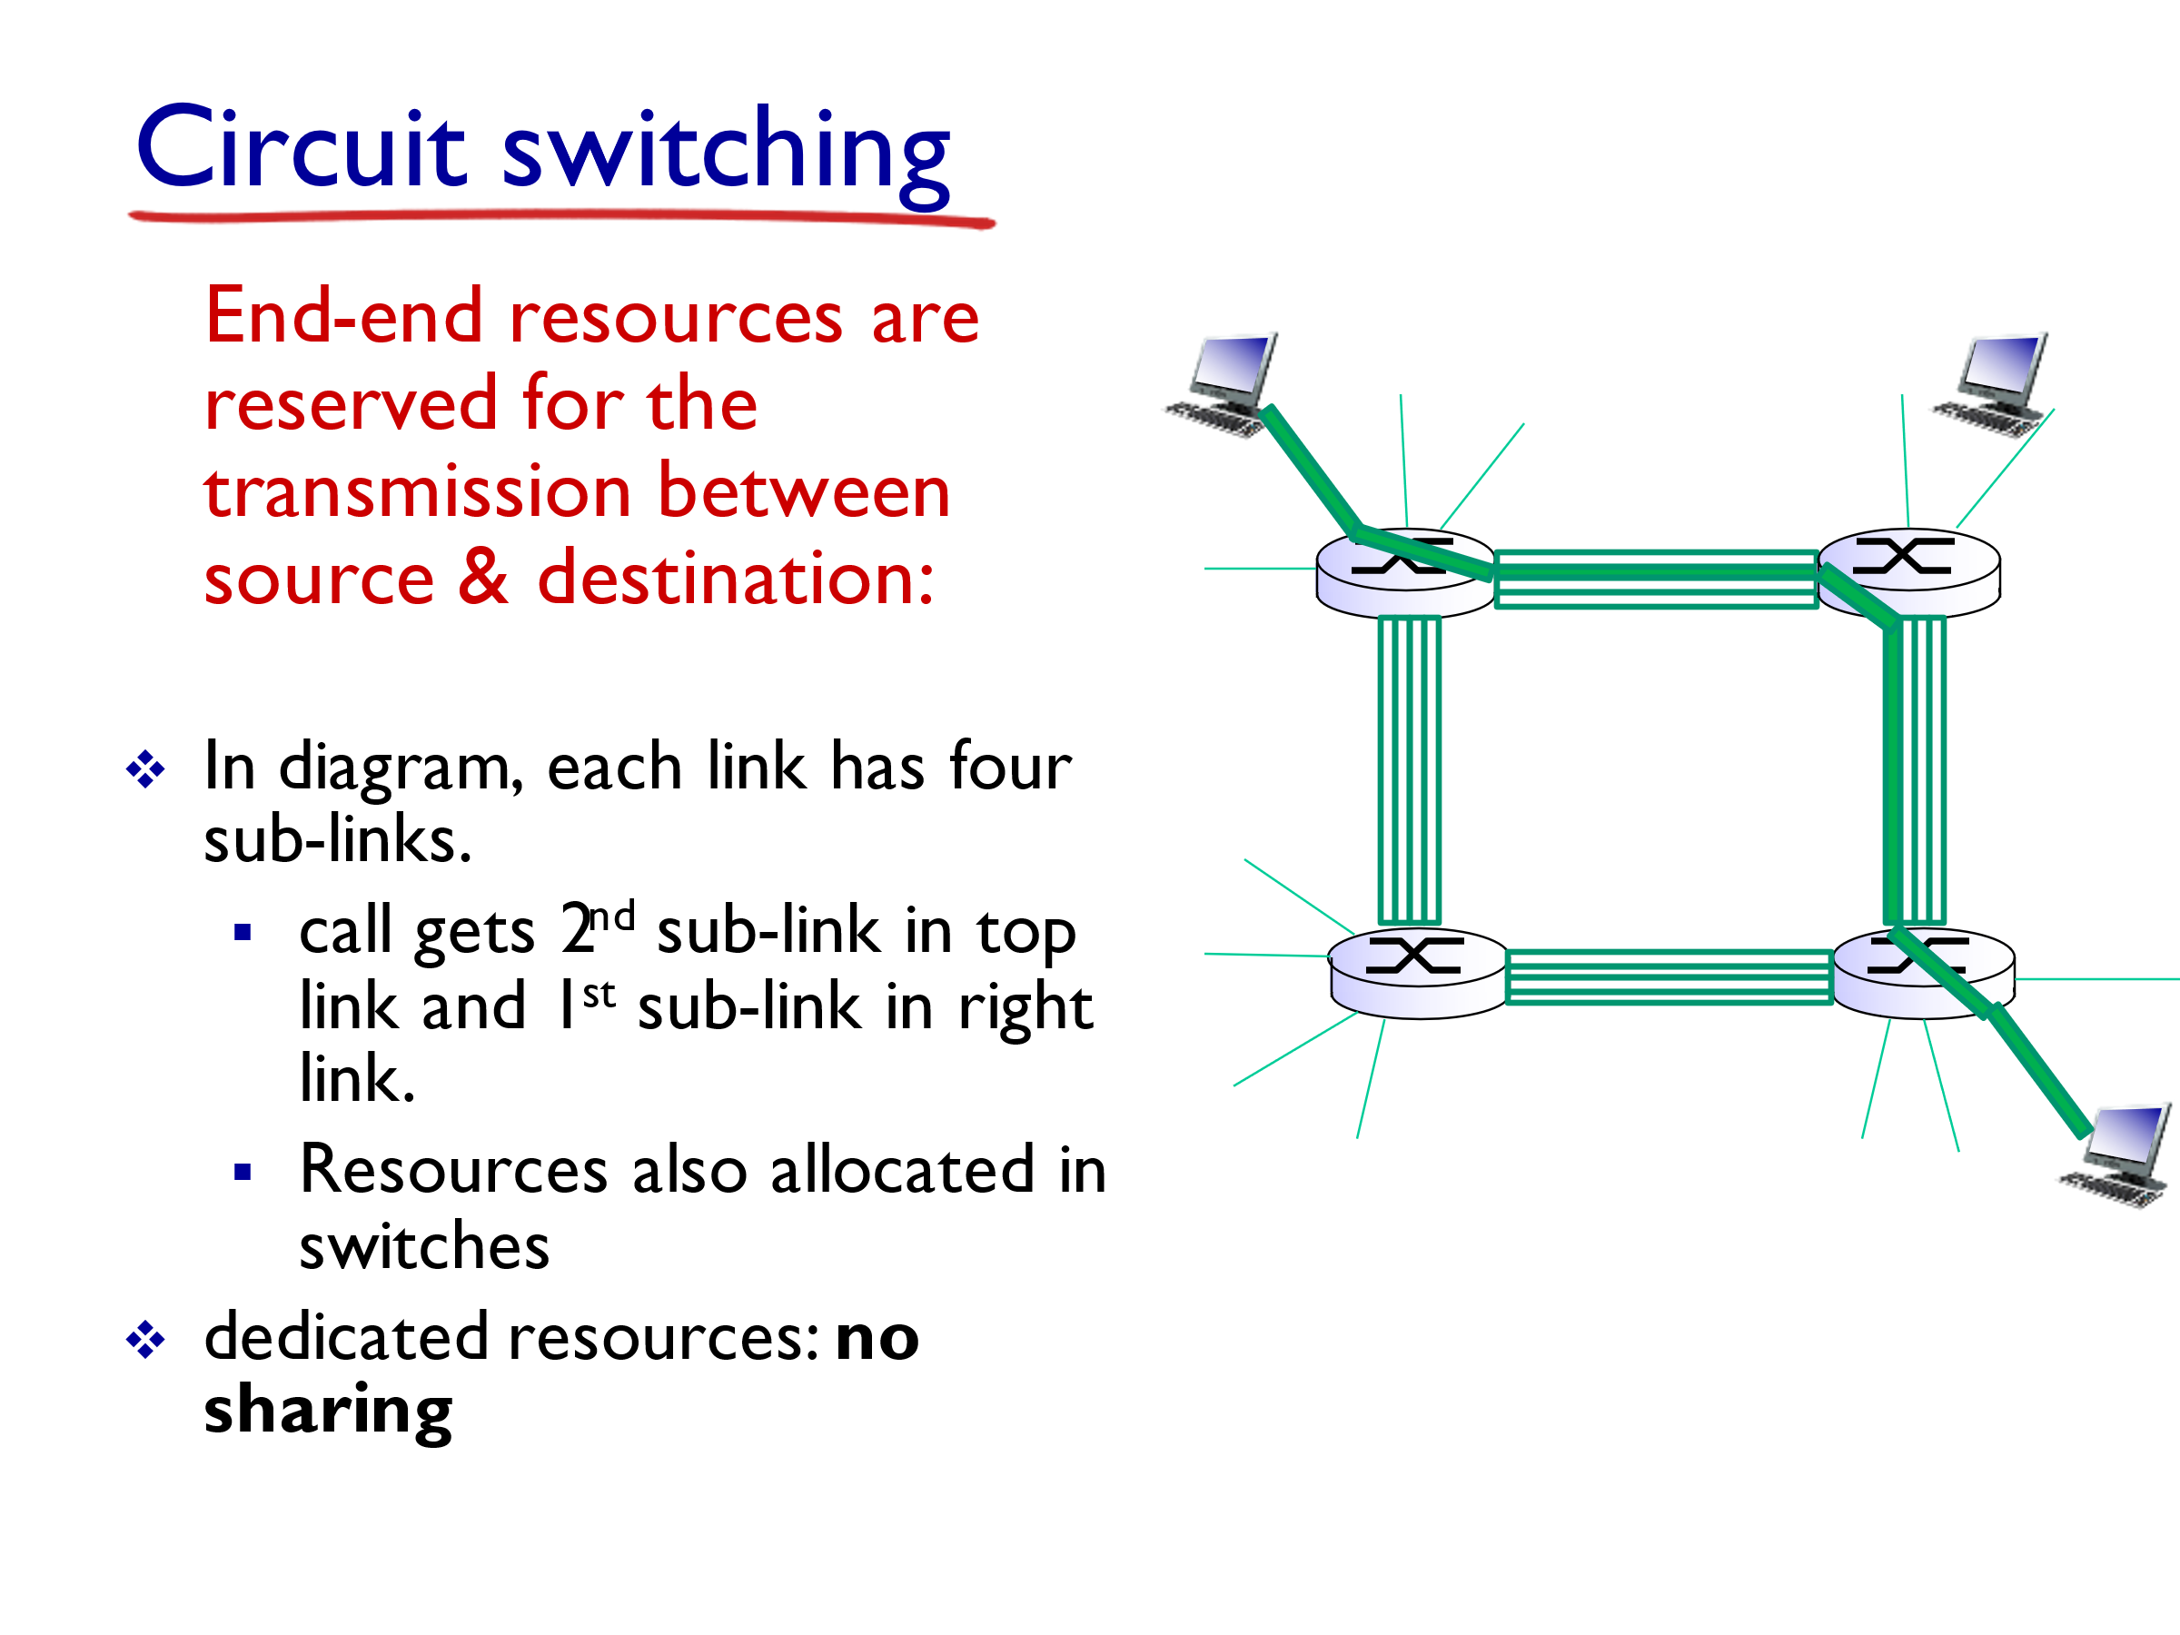

* circuit sub-link is idle if not used by call *(no sharing)*
* Advantages: no competition for use
* Disadvantages: limited, low efficiency.

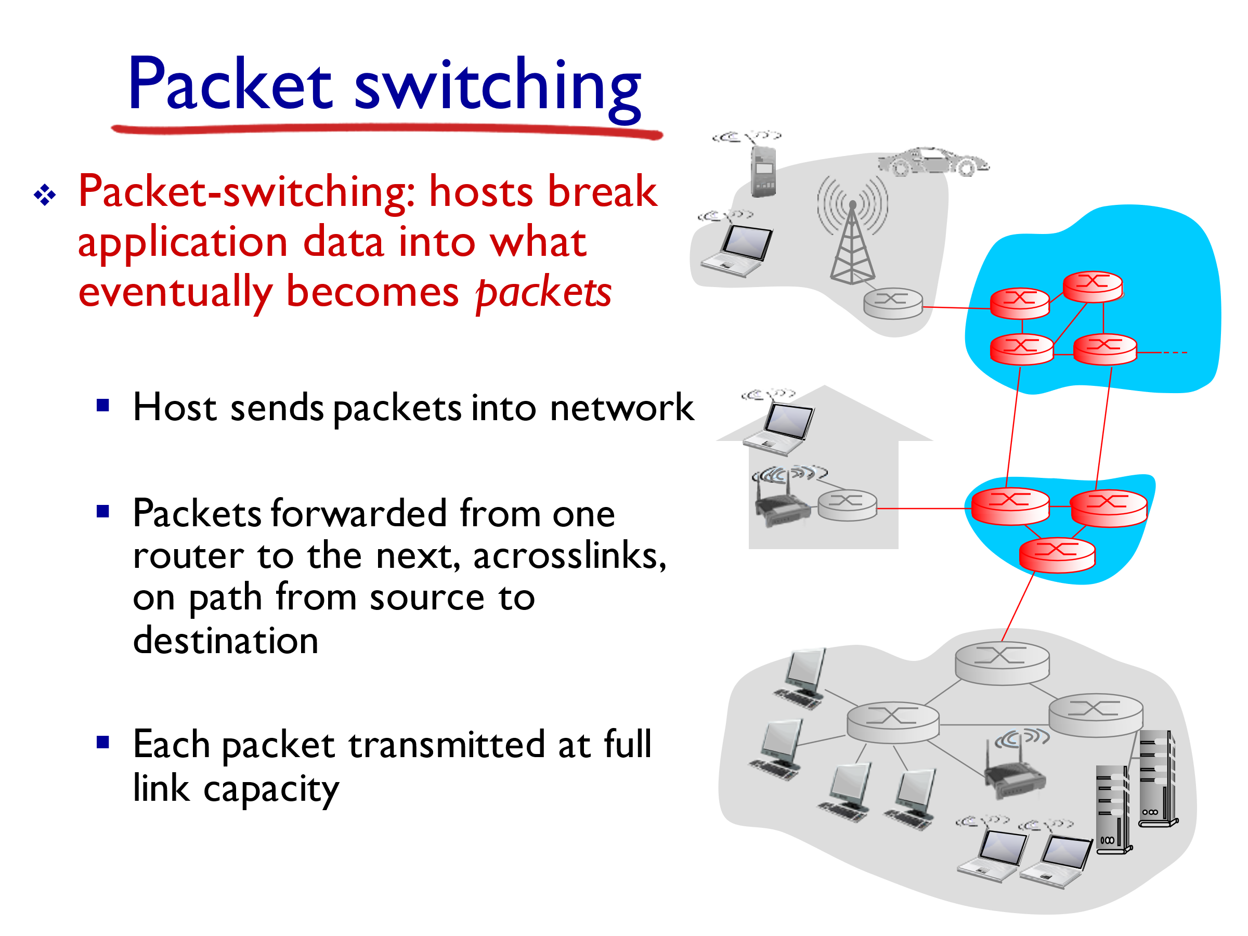 

**How can we accommodate more than one user to transmit**

**over a given link?**

* The transmission links in a subnet usually carry traffic from several users.
* How this traffic is combined onto a link is referred to as Multiplexing.
* The reason for this is primarily economic.

**Multiplexing techniques**

* There are several methods for multiplexing multiple flows onto one physical link.
* Multiplexing techniques can be divided into **static** and **dynamic (a.k.a statistical or asynchronous)**  approaches.
* **Circuit switching** is used with static multiplexing techniques; this is the approach used in the public telephone network.
* **Packet switching** is used primarily with **dynamic multiplexing**, this is the approach used in most data networks, such as the Internet.

**Static Multiplexing Techniques**

* Time division multiplexing (**TDM**)
* Frequency division multiplexing (**FDM**)
* The idea of TDM is to divide time into equal-sized time slots and, in a round-robin fashion, give each flow a chance to send its data over the physical link. This quantum is reserved for this user, whether data is available to be sent or not.

**Example:**

If 4 messages are sent from region A to region B, using the Public Switched Telephone Network (PSTN), these messages are multiplexed over the channel going from A to B.

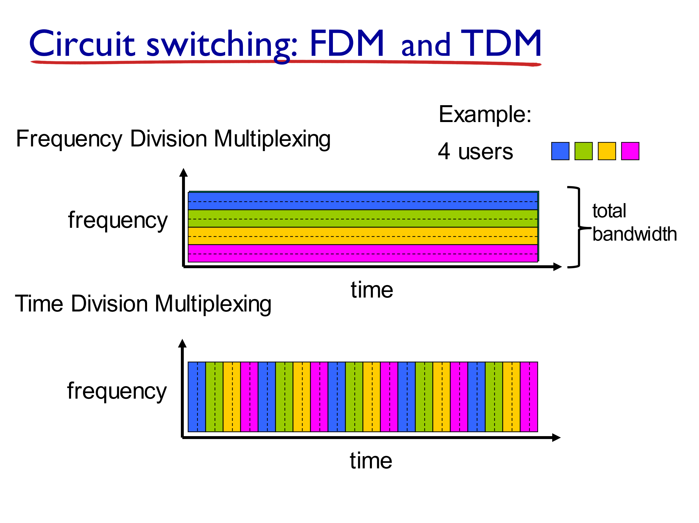

* **Frequency-division multiplexing (FDM)**. The idea of FDM is to transmit each flow over the physical link at a different frequency, much the same way that the signals for different TV stations are transmitted at a different frequency over the airwaves or on a coaxial cable TV link.

**Example:**



Both TDM and FDM are **limited**. If one of the flows (host pairs) does not have any data to send, its share of the physical link—that is, its time quantum or its frequency—remains idle, even if one of the other flows has data to transmit.

**Statistical (i.e. dynamic or asynchronous) Multiplexing** is usually implemented at the packet level.

* Like TDM, the physical link is shared over time.
* However, data is transmitted from each flow **on demand** rather than during a predetermined time slot.

**Example:**

**Transmission Time Versus Propagation Time**

* **Transmission Time** is the time it takes the router to output the bits onto the link.

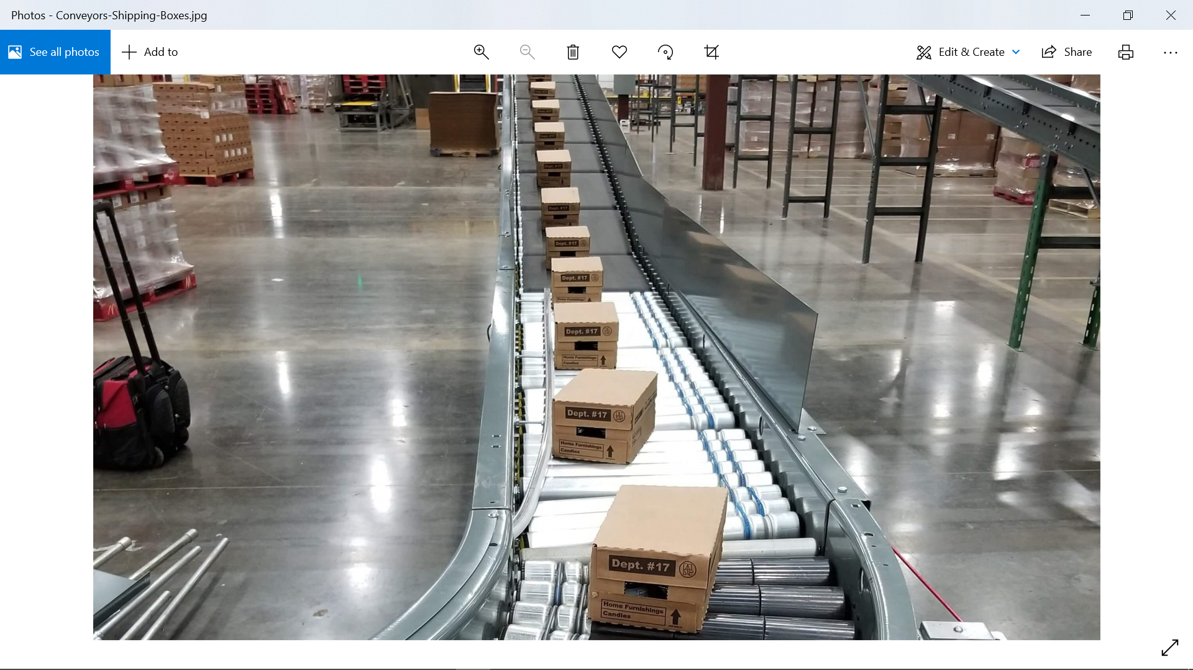

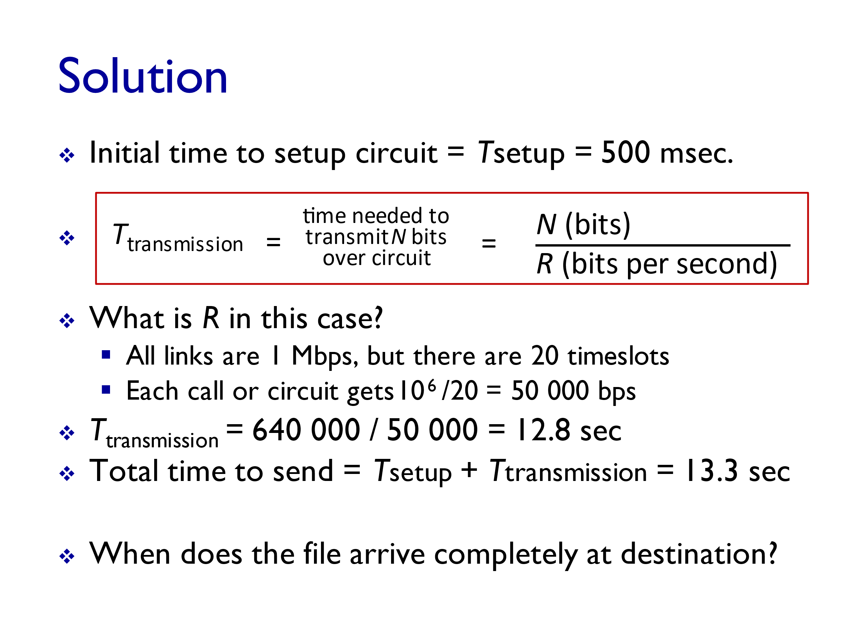

* **The propagation Time** is the time it takes the bits to move across the links until they reach the destination

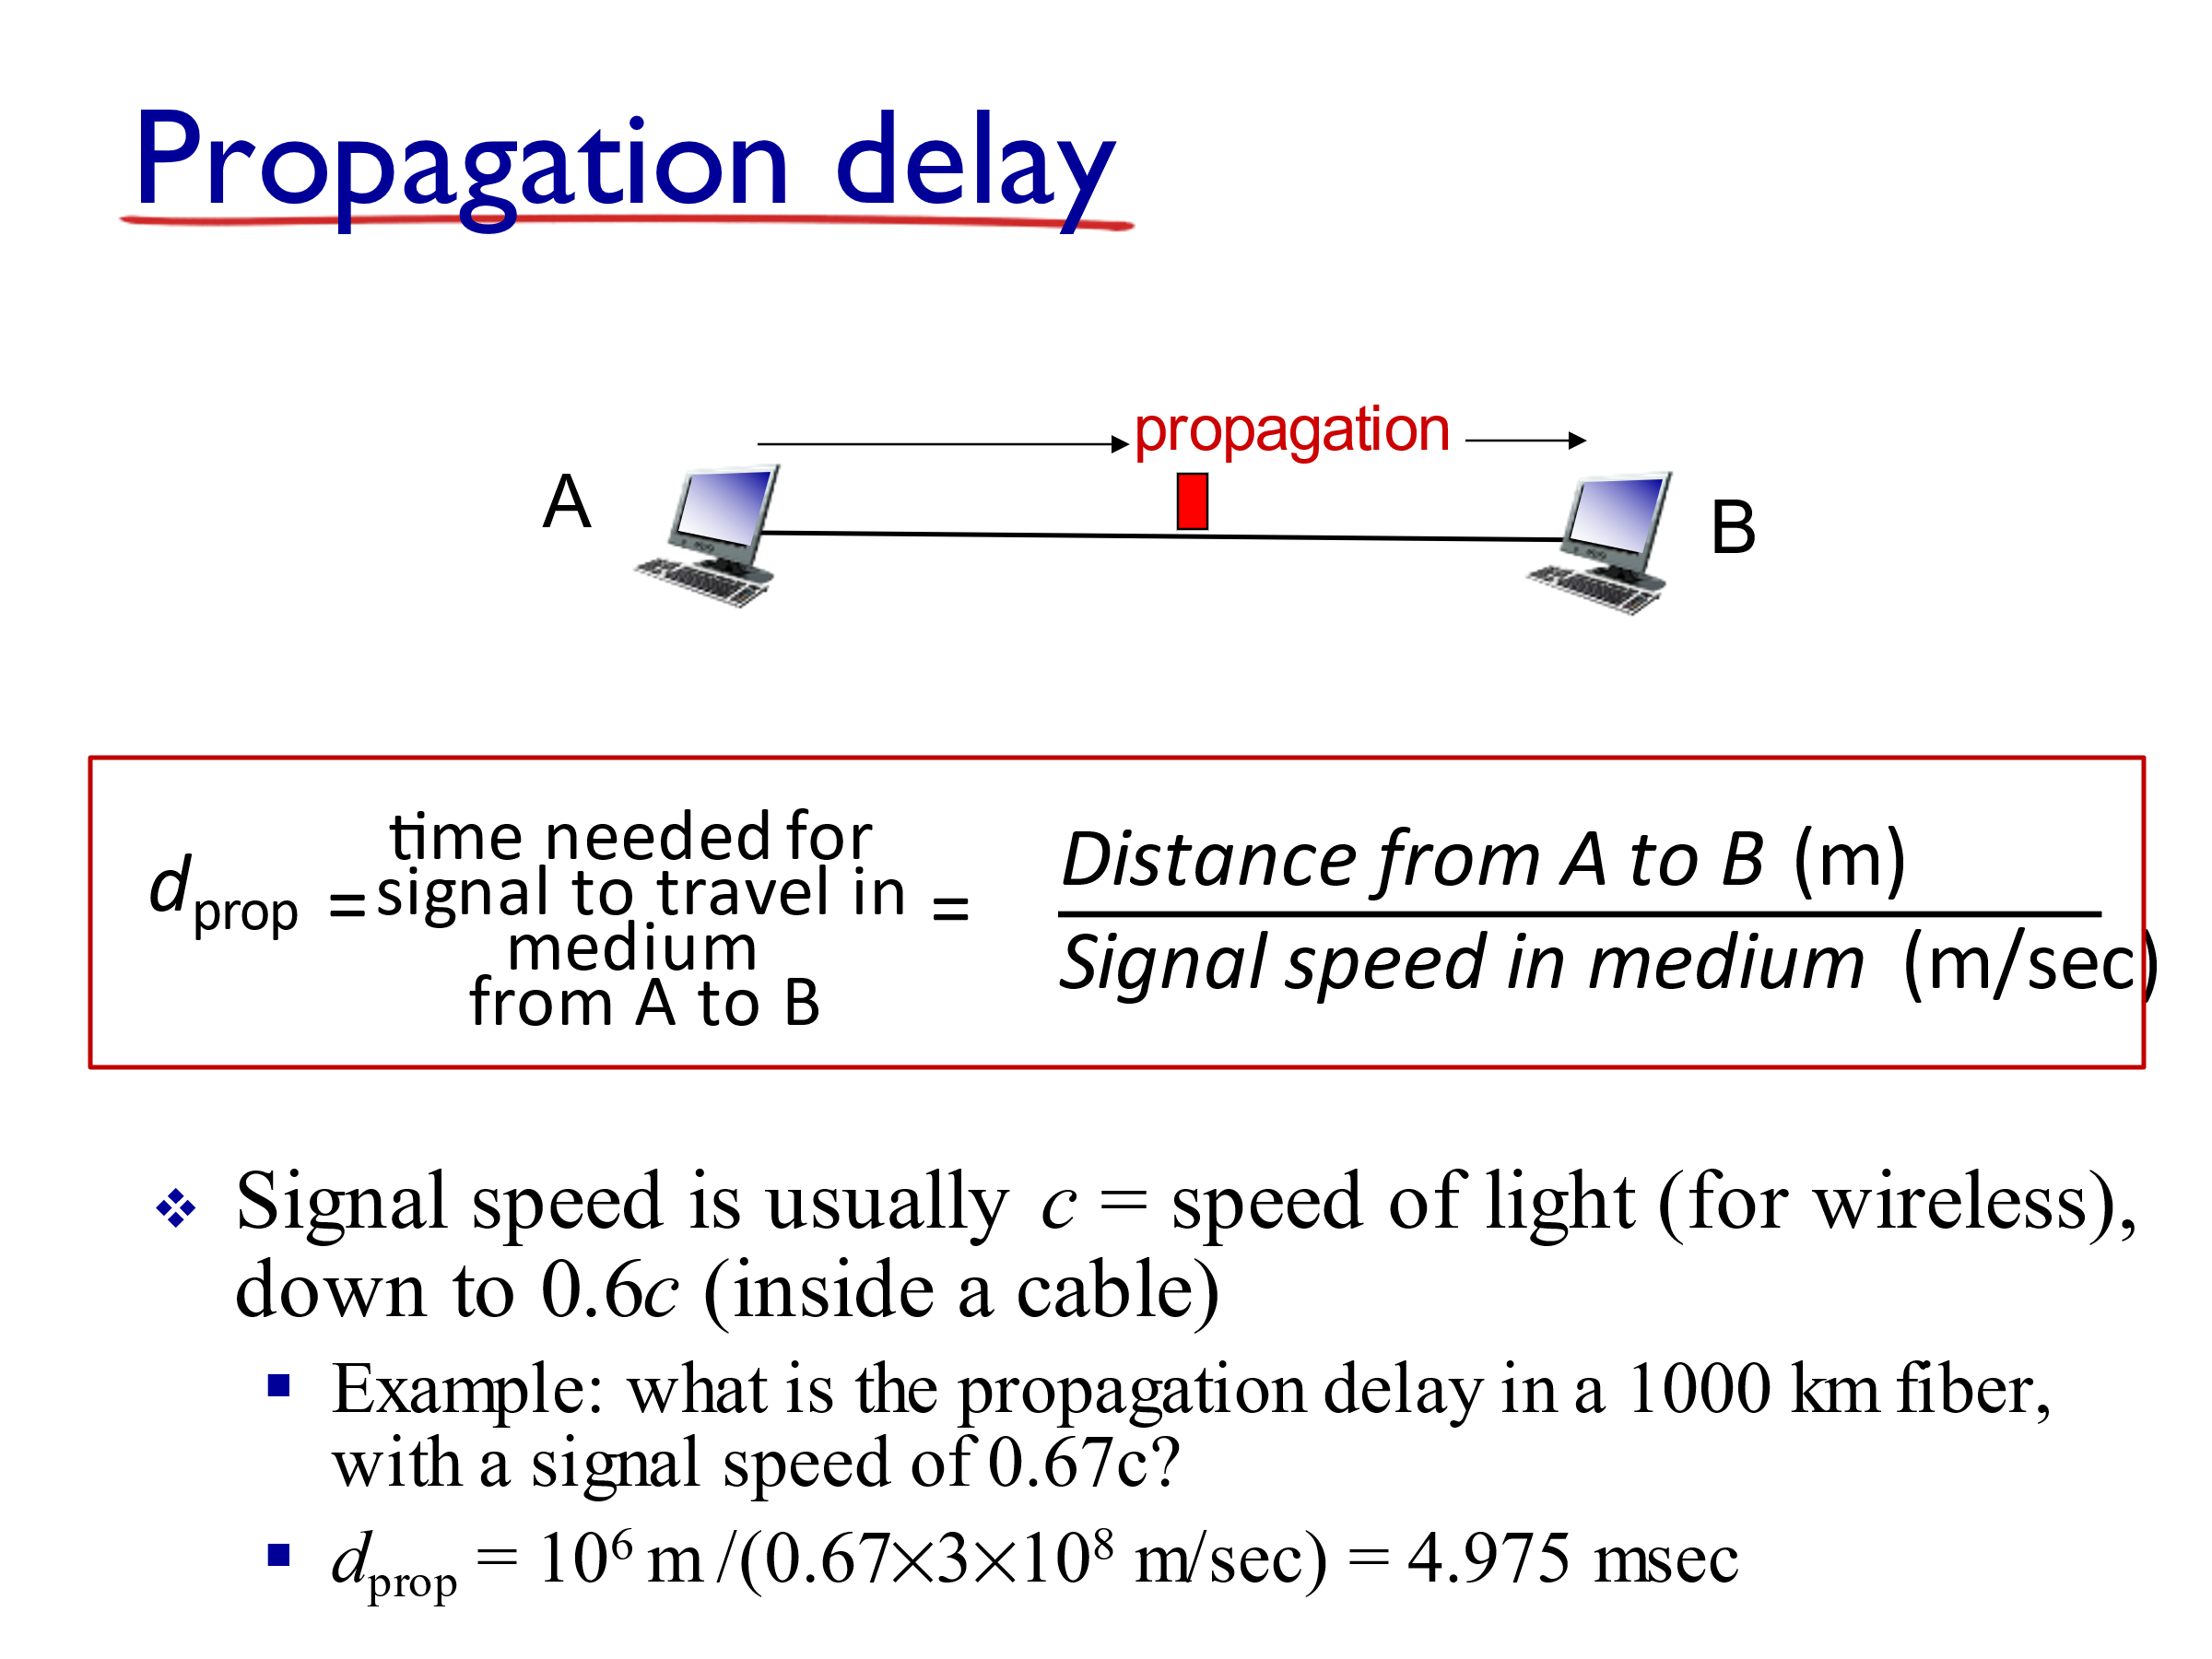

But it is 0.67c (inside a cable)

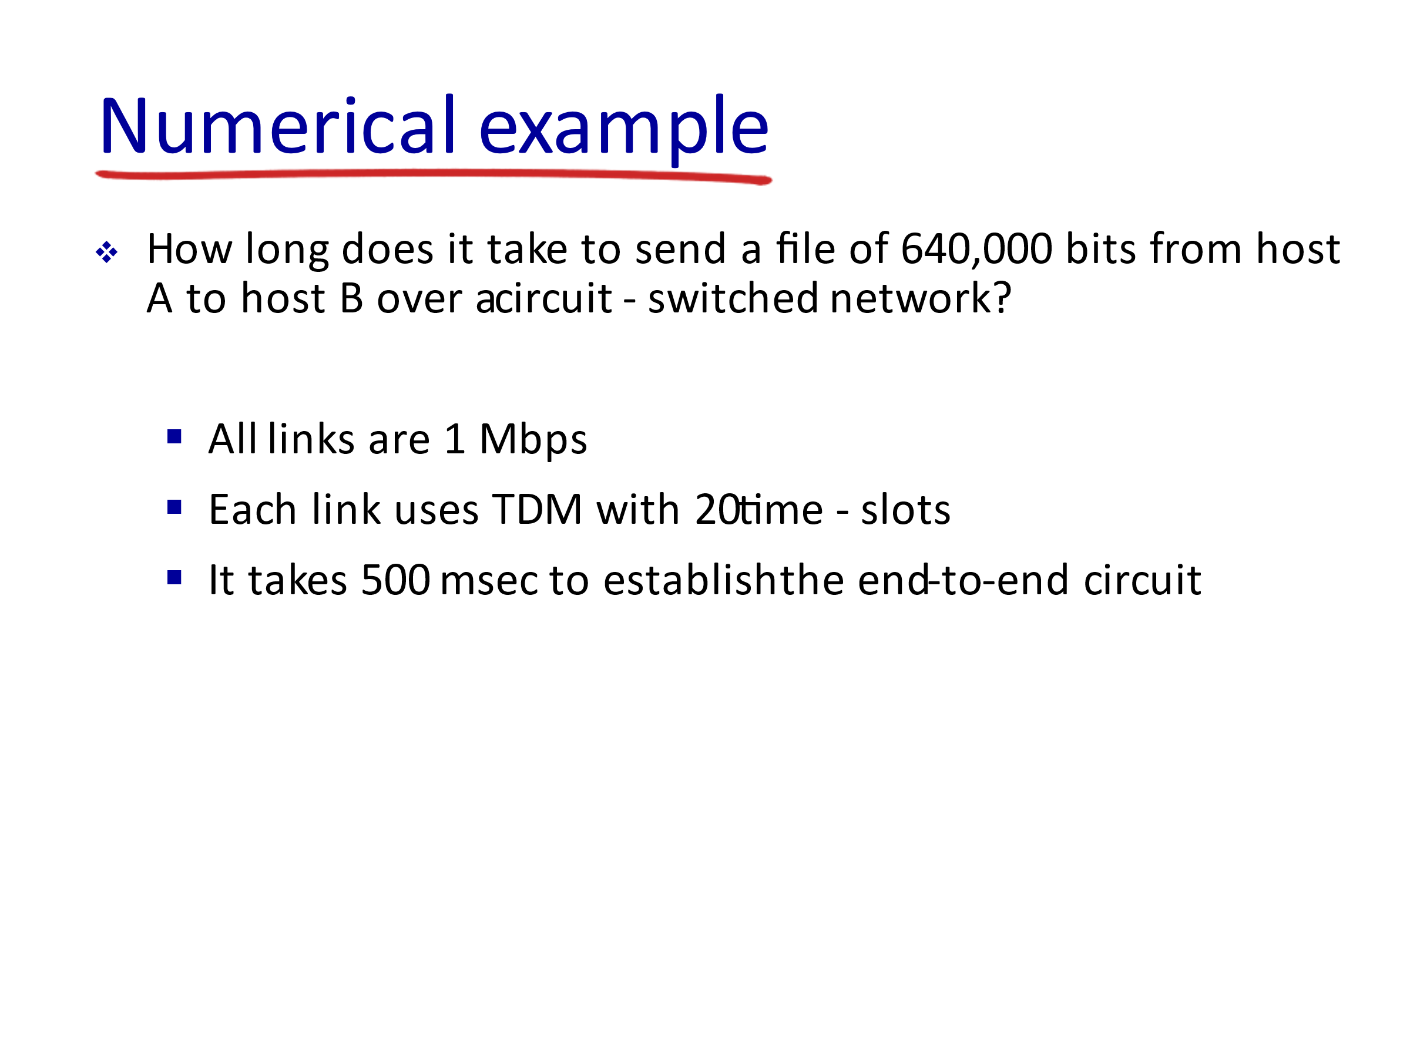

This is the transmission rate R



Discussion 2:

Find the time to send the file. (Since I didn’t mention anything about the propagation speed, do not include the propagation delay in your computations yet)

Since the transmission rate of only one slot will be used by each user then we have to calculate the transmission rate per time slot and not use the total transmission rate since it’s not fully used (since the whole bandwidth is not used at all time).



This is the time to establish the circuit and transmit the bits (i.e. output the bits on the link)

We didn’t account for the propagation delay yet

**Discussion 3**

cable



Note that the propagation delay is independent of the number of bits



Discussion 3 Solution:





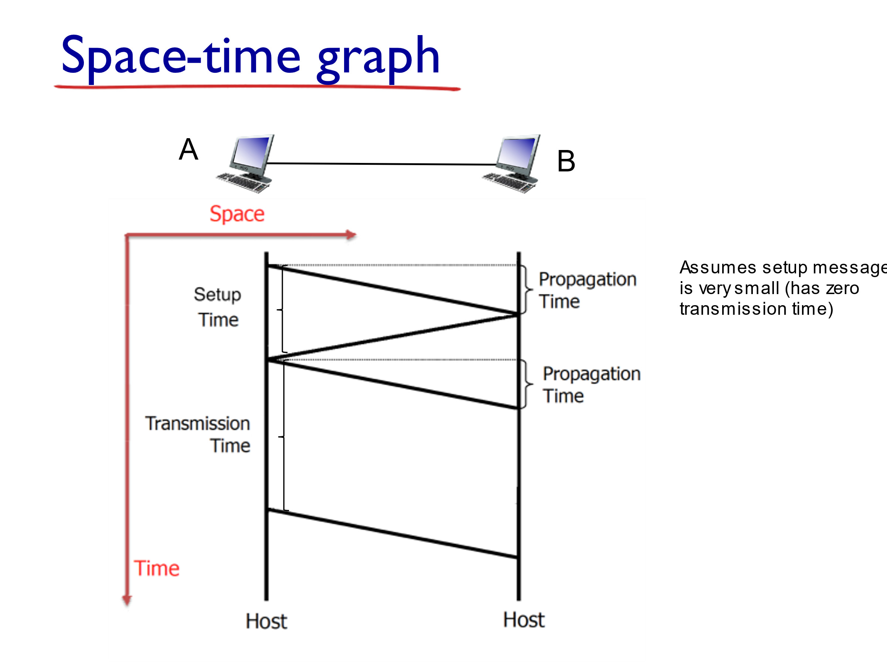

Pay attention to the assumptions given in a problem

Start: time = 0

Finish: Last bit arrives at B

**??**

Last bit is transmitted

First bit is transmitted

* In Circuit-switched networks, a connection has to be established between A and B, before transmission can start (this is called setup).
* During **setup**, a small message is sent **from A to B**, to ask for a connection.
* Then, an acknowledgment is sent from **B to A** to inform A that the connection is established.
* Once this is done, transmission can start.

**Important Note**

What is 1Mega and 1Gega?????

When referring to **Memory sizes or Data sizes as powers of 2**, we usually add an “i” to KB, MB, GB and use KiB, MiB and GiB.

while 1 KiB = 210 = 1024 Byte (**kibi**byte)

1 MiB = 1024 KiB = 220 Bytes. The mebi prefix in **Mebi**Byte (MiB) stands for **mega and binary** – which refers to it as being a power of 2

1 GiB (gibibyte) = 230 Bytes

When “i” is not used, use powers of 10 to translate KB, MB, GB.

Capital B = Byte, whereas b = bit

1MB=1million Bytes = 106 Bytes = 8*106 bits

1Kilo = 103 , 1Mega = 106 , and 1Gega = 109

ex: 1Mbps (Mega bits per sec) = 106 bits per sec

1Mbytes/sec = 106 * 8 = 8 * 106 bits per sec

1Gbps (Gega bits per sec) = 109 bits per sec



Discussion 4: Which transmission has better throughput???

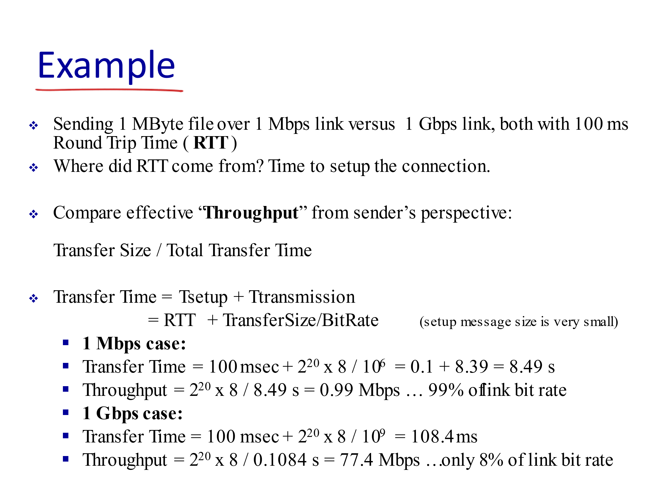

Propagation time is not added, even if it is given in the problem. Transfer time only includes setup time + transmission time for circuit switched transmission. It is total time until all bits are placed on link

Effective bps

RTT = setup time

1 MiB

Discussion 4 Solution

Throughput or Effective throughput for circuit switch transmission is the “effective bit” rate, I.e. total bits transmitted/total time needed until all bits are placed on link



1 MiB



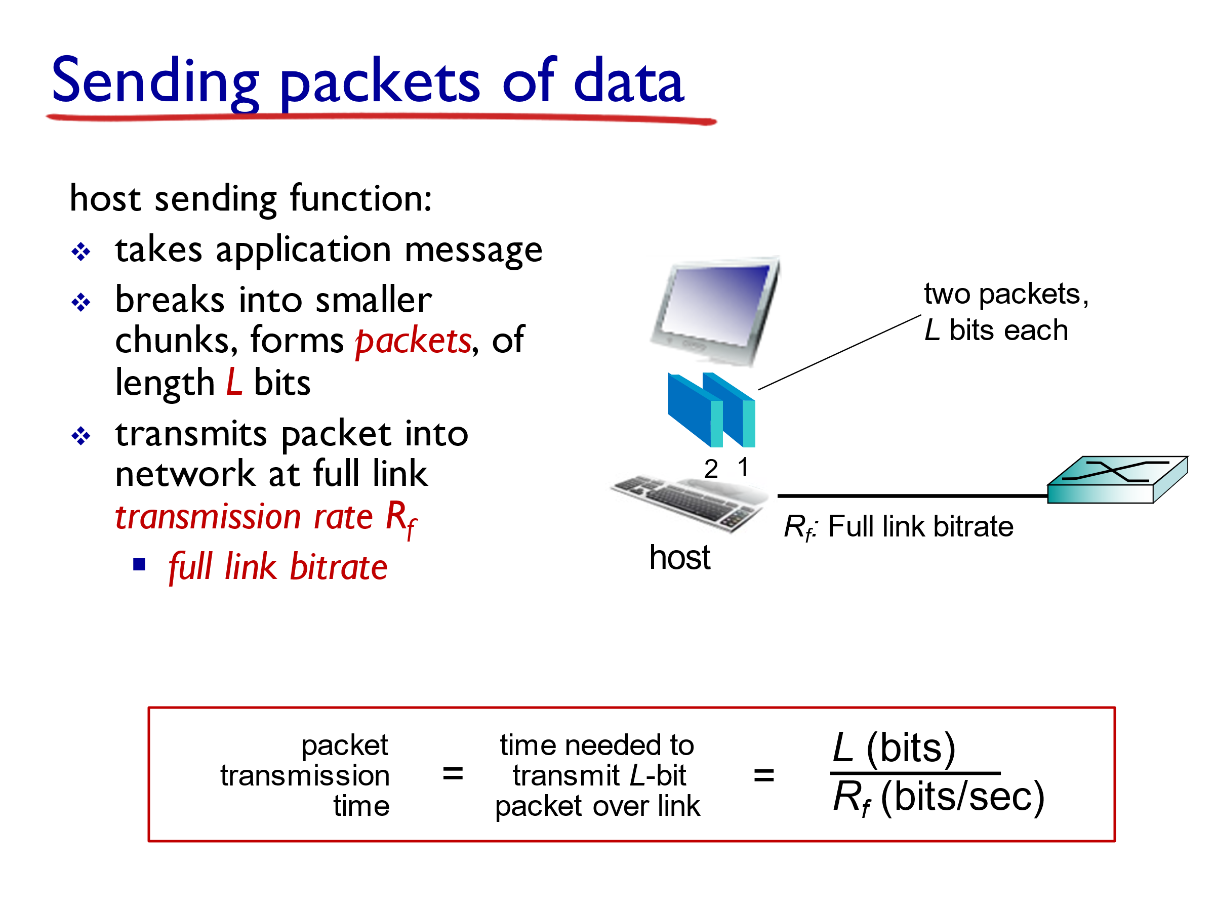

*R*

transmission rate R

transmission rate R

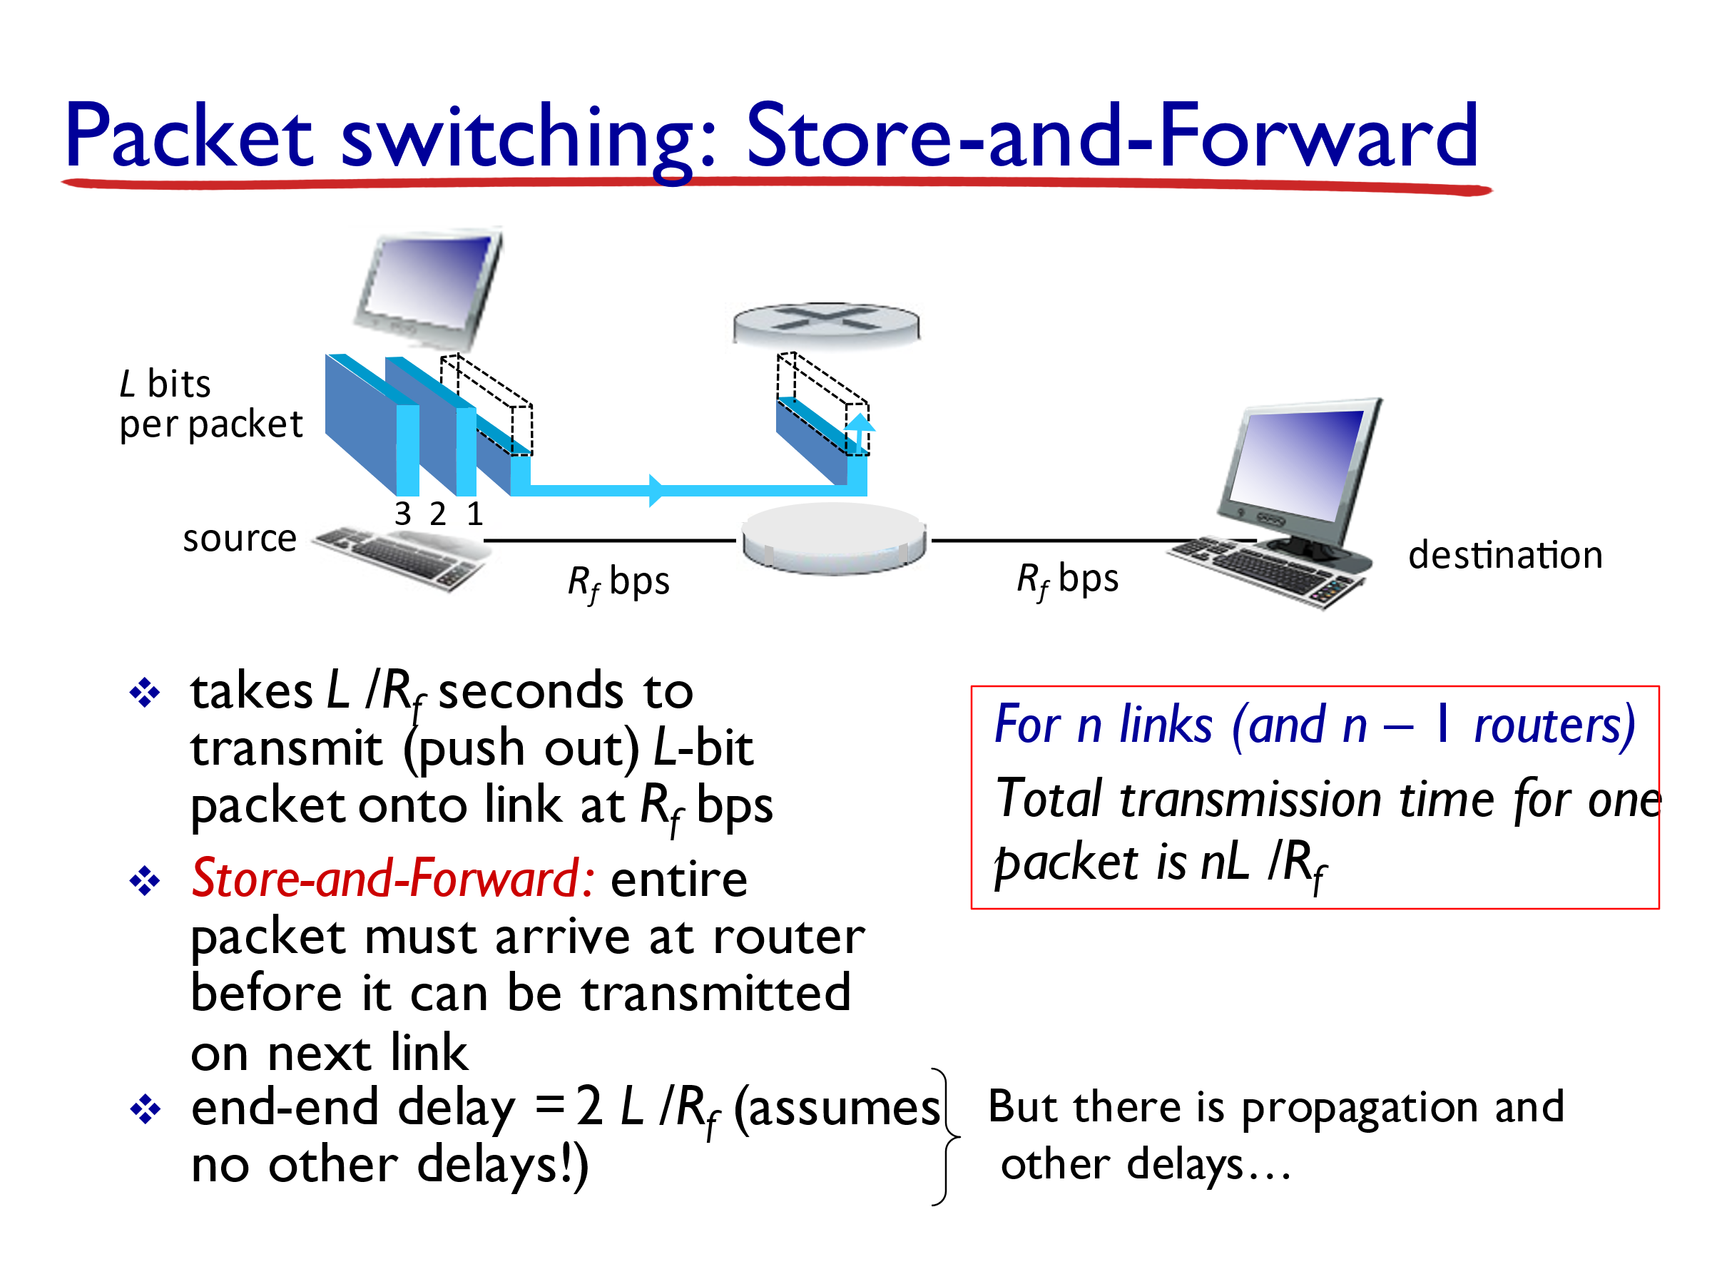

*Transmission delay*

*R*

*R*

*R*

*R*

*R*

*R*

**Delay in Packet-Switched Networks**

this is referred to as *Queuing Delay*





*R*

*R*

*= transmission rate*

*R*

**Question 2:**

**In the following question, you will use Little’s law which relates the average number of items in a queuing system such as a restaurant or a store (This is the** **sum of the items in the queue and the items being served), the average time in the system for an item (in the queue plus in the store) and the average number of items arriving per unit time.**

Let L =average number of items in the queuing system (sum of the items in the queue and the items being served),

D = average time in the system for an item (in the queue plus in the store), and λ =average number of items arriving per unit time,

the law states the following:

L = λ D

“The long-term average number of customers in a stable system is equal to the long-term effective arrival rate multiplied by the average time a customer spends in the store.”

Consider a **router buffer** preceding an outbound link. In this problem, you will use Little’s formula, a famous formula from queuing theory. Let ***N*** *denote the average number of packets in the buffer plus the packet being transmitted*. Let ***a***denote the *rate of packets arriving at the link*.

Let *d* denote the **average total delay** (i.e., the **queuing delay plus** the **transmission delay**) experienced by a packet. Little’s formula is **N = a.d**.

Suppose that on average, the buffer contains 10 packets, and the average packet queuing delay is 10 msec. The link’s transmission rate is 100 packets/sec. Using Little’s formula, what is the average packet arrival rate, assuming there is no packet loss?

Discussion 5 Find N and d

**Solution:**

The total number of packets in the system includes those in the buffer and the packet that is being transmitted. So, N=10+1.

**average total delay** = d = the **queuing delay plus** the **transmission delay** =

= 10 msec/1000 + 1packet / (100packets/sec)

= 0.01 sec + 0.01 sec = 0.02 sec

Because *N*=*a*⋅*d*, so (11) = **a**\*(0.02). Thus, a=550 packets/sec.

**Discussion 6**

Visit the **Transmission Versus Propagation Delay applet** at the companion Web site.

a) Among the rates, propagation delay, and packet sizes available, find a combination for which the

sender finishes transmitting before the first bit of the packet reaches the receiver.

b) Find another combination for which the first bit of the packet reaches the receiver before the sender finishes transmitting.

[**https://media.pearsoncmg.com/aw/ecs_kurose_compnetwork_7/cw/content/interactiveanimations/transmission-vs-propogation-delay/transmission-propagation-delay-ch1/index.html**](https://media.pearsoncmg.com/aw/ecs_kurose_compnetwork_7/cw/content/interactiveanimations/transmission-vs-propogation-delay/transmission-propagation-delay-ch1/index.html)

**Solution**

a**) 1000 km, 1 Mbps, 100 bytes** (several other combinations, for ex 100Km, 100Mbps, 1Kbytes, …)

b) **100 km, 1 Mbps, 100 bytes** (several other combinations exist, for ex: 10km, 1Mbps, 100bytes: slow)

**Discussion 7**

Suppose Host A wants to send a large file to Host B using packet switching. The path from Host A to Host B has two links, of rates Rs and Rc bps.

Assuming no other traffic in the network, what is the throughput for the file transfer?







**Solution** Throughput = min(Rs, Rc)

**Question 3:**

In packet switching with store-and-forward, a packet needs to be received in full at a switching node or router before it can be placed on an outgoing link and transmitted. Consider a linear path consisting of a source host, a destination host and 2 intermediate routers, (there are 3 intermediate links). The source has 5 packets of size 5000 bits each. All links have a propagation delay of 4 msec and a bit rate of 100 kbps. Neglect processing and queuing delays at the intermediate switches/routers.

a) How long it takes to receive packet 1 at the destination host?

b) How long it takes to receive all 5 packets at the destination host?

c) **Draw a time-space graph of this problem**.

Solution

It takes ttr = 5000bits/100 kbps = 50msec to transmit package 1 then tpr = 4msec to propagate it to Router1. By the time the last bit of package 1 arrives at Router1, the preceding bits are already accepted by the router (time it takes router j to receive the bits is overlapped with time tpr on previous link and ttr of router j-1). So it takes the packet ttr+tpr for each hop across a link.

a) packet 1 arrives after: 3*ttr + 3*tpr

tpr

Time

1st bit prop

last bit prop

ttr

Last bit

tpr

tpr

b) The N packets are transmitted back to back. Immediately after the source transmits packet 1, it starts transmitting packet 2, therefore by the time packet 1 is received by destination, all N-1 = remaining 4 packets follow and arrive at destination at time: 7*ttr + 3*tpr

Time

packet transmission time

prop. time

In packet switching with *store-and-forward*, a packet needs to be received in full at a switching node or router before it can be placed on an outgoing link and transmitted. In *cut-through switching*, as soon as the first hundred or so bits of the packet (referred to as header) are received, the outgoing link can be determined, and if it is free, transmission can start *immediately* on that link. Suppose there are 125 header bits in each packet, How long it takes to receive all 5 packets at the destination host?

Time

Cut through:

5*ttr+ 3*tpr + 2*125/100,000

**Recitation**

**Question A:**

Suppose users share a 2 Mbps link. Also suppose each user transmits continuously at 1 Mbps when transmitting, but each user transmits only 20 percent of the time.

a. **Discussion** When circuit switching is used, how many users can be supported?

Solution

In circuit switching, static multiplexing is used. It doesn’t matter whether the user is transmitting 20% or 100% of the time.

2 users can be supported because each user requires half of the link bandwidth

b. **Discussion** For the remainder of this problem, suppose packet switching is used. Will there be essentially any queuing delay before the link if **two or fewer users** transmit at the same time? Why?

Will there be a queuing delay if **three users** transmit at the same time? Why?

Solution

Since each user requires 1Mbps when transmitting, if two or fewer users transmit simultaneously, a maximum of 2Mbps will be required. Since the available bandwidth of the shared link is 2Mbps, there will be no queuing delay before the link.

Whereas, if three users transmit simultaneously, the bandwidth required will be 3Mbps which is more than the available bandwidth of the shared link. In this case, there will be queuing delay before the link.

**Question B:**

Suppose Host A wants to send a large file to Host B using **packet switching**. The path from Host A to Host B has three links, of rates R1=500 kbps, R2=2 Mbps, and R3=1 Mbps.

1. **Discussion** Assuming no other traffic in the network, what is the **throughput** for the file transfer?

Solution

a) 500kbps

**Question C:**

Consider the following **circuit-switched** network.



A

D

C

B

Figure 1.13 A simple circuit-switched network consisting of **four** switches and **four** links

Recall that there are 4 circuits on each link. Label the four switches A, B, C, and D, going in the clockwise direction. For the following questions, you answer should list the actual connections.

a. **Discussion** What is the **maximum** number of simultaneous connections that can be in progress at any one time in this network?

Solution

1. Between the switch in the upper left and the switch in the upper right we can have 4 connections. Similarly we can have four connections between each of the 3 other pairs of adjacent switches. Thus, this network can support up to 16 connections
2. **Discussion** Suppose that all connections are between switches A and C. What is the maximum number of simultaneous connections that can be in progress?

Solution

1. We can have *4* connections passing through the switch in the upper-right-hand corner and another *4* connections passing through the switch in the lower-left-hand corner, giving a total of *8* connections.

c. Suppose we want to make four connections between switches A and C, and another four connections between switches B and D. Can we route these calls through the four links to accommodate all eight connections?

**Solution**

1. Yes. For the connections between A and C, we route two connections through B and two connections through D. For the connections between B and D, we route twoconnections through A and two connections through C. In this manner, there are at most 4 connections passing through any link.

Additional Questions

**Question #D**

A packet switch receives a packet and determines the outbound link to which the packet should be forwarded. When the packet arrives, one other packet is halfway done being transmitted on this outbound link and four other packets are waiting to be transmitted. Packets are transmitted in order of arrival. Suppose all packets are 1,500 bytes and the link rate is 2 Mbps.

a) What is the **queuing** delay for the packet? (i.e. The time until it is its turn to be transmitted)

b) More generally, what is the queuing delay when all packets have length L, the transmission rate is R, x bits of the currently-being-transmitted packet have been transmitted, and n packets are already in the queue?

**Solution:**

The arriving packet must first **wait for the link to transmit** **4.5 *1,500 bytes** = 6,750 bytes or 54,000 bits.

Since these bits are transmitted at 2 Mbps, the queuing delay is 54000 /( 2* 106 ) = 27 msec. Generally, the queuing delay is **(*nL* + (*L* - *x*))/*R*.**

P2P: Peer-to-Peer, DNS: Domain Name System, UDP: User Datagram Protocol, TCP: Transmission Control Protocol, NAT: Network Address Translation, LS: Link-state routing alg., DV: Distance-Vector Routing alg., ISP: Internet Service Provider, OSPF: Open Shortest Path First, BGP: Border Gateway Protocol